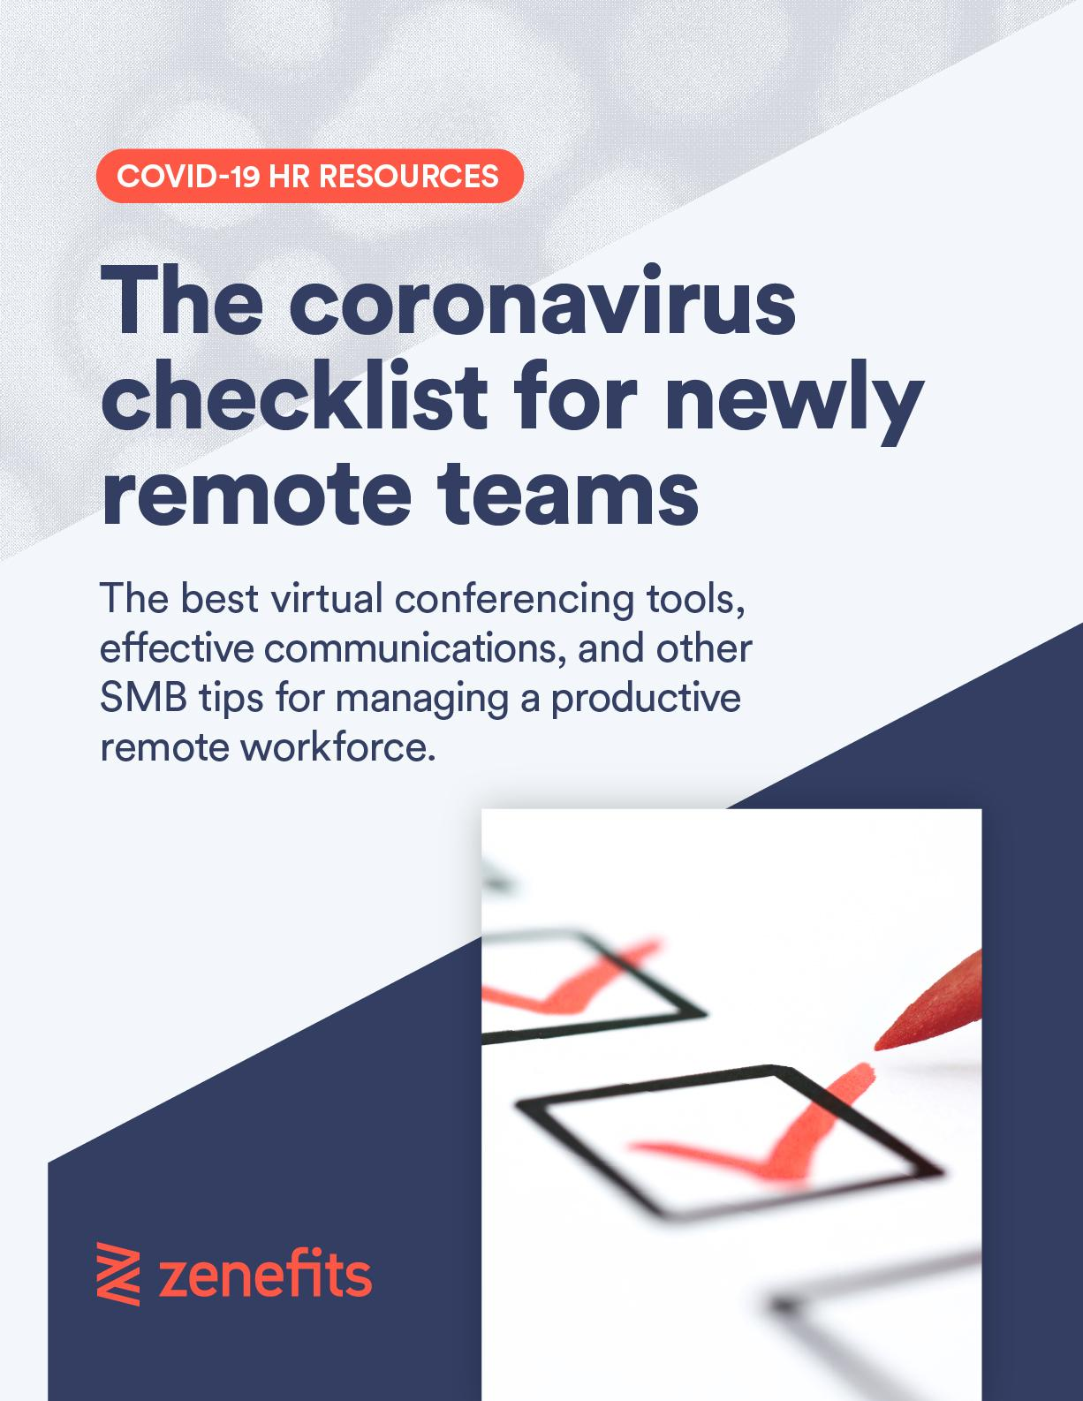

The Coronavirus Checklist
for Newly Remote Teams

This checklist was built for small and midsize businesses dealing with new work-from-home policies due to the ongoing coronavirus outbreak.

The goal is to provide practical action items to ensure business owners, operations, HR admins, and employees make a smooth transition to working from home without losing productivity. Feel free to edit the checklist as much or as little as you want, and send it as a staff memo, too.

CONTENTS:
- Setting up your workspace
- Employee Time Tracking & Scheduling
- Virtual conferencing set-up and expectations
- Communications from managers to staff
- How to host, or attend, virtual meetings
- Expenses
- Working hours
- Customer communications
- Managing housemates and family who are also home

ALL EMPLOYEES

Setting up your workspace

The first step to successful remote working is designating a specific work location in your home. This allows you to mentally and physically become present for work activity, and it helps you ignore other pressing household tasks.

Ensure you and your teams have a designated space to perform their work, even if that’s a particular seat in the kitchen.
- Designate a singular place for work.
- Get the appropriate equipment to be as productive as possible in your new work space. Stores may be closing, and supplies limited, but do the best you can. Based on your role in the company this could include:
  - Separate monitor
  - Detached mouse
  - Detached keyboard
  - Electrical outlets
  - Appropriate air ventilation and lighting
- Communicate to your housemates that “this” is your area for work. Encourage them to respect your needs and boundaries to be productive, by limiting distraction during work hours. Setting clear boundaries ahead of time helps people know when it’s okay to talk, and when it’s not.

HR ADMINS & ALL EMPLOYEES

Employee Time Tracking
& Scheduling

You’ll need a way to track employee worked hours remotely, particularly if you have hourly or scheduled employees. The best way to do this is by using a mobile-friendly time and attendance tracker,
like Zenefits’ Time & Scheduling application.

Mobile time and scheduling tools allow users to clock-in and clock-out directly from their mobile phone, providing real-time accountability to managers. Some apps automatically sync with payroll so you’re not spending time inputting remotely logged hours into a local spreadsheet.

Special Note:
If you have any of the below needs, please reach out to Zenefits today to get set up quickly, and enable your entire staff remote with mobile-phone based time tracking.
- Start Work Anywhere
Our desktop and mobile apps help your team track hours from anywhere –whether they’re remote, in the field, or at the office.
- Record Clock-in Location
You can choose to record the location of your workers’ clock in, giving visibility on employee whereabouts when they start and stop work.
- Time Card Fraud Protection
Fraud detection services (like pictures taken at clock in) gives you the confidence that your team is showing up to get the job done.
- Reporting
Understand your team’s activities through real-time reporting, including information on clock ins and outs, how many hours each project has accrued, and analytics on overtime pay.
- Built-in Compliance
Get the tools you need to help stay compliant with labor laws through automatic breaks and lunch notifications, ACA compliance features, and overtime regulations.
- Sync
And, most importantly, Zenefits syncs with systems you already have in place
— like Xero, Quickbooks, Expensify, and more.
Call today for emergency implementation of Remote Time & Scheduling:
(888) 249-3263
HR Admins
- Ensure you have remote-enabled employee time tracking and scheduling available to all employees. Here are some qualifying questions as you find a solution.
  - Does the time and schedule app automatically sync with payroll?
  - Is it quick and easy to implement?
  - How hard will it be for employees to understand the new application?
- Send an email reminder to staff, ensuring each employee has downloaded the mobile app and practiced clocking-in and clocking-out.
  - Are there special needs like lunch breaks?
  - What types of employees do you have?
  - How many states do you operate in?

- Zenefits runs Time & Attendance tracking and payroll in all 50 states — making managing your tax compliance easy peasy.

All Employees
- Use your mobile time tracking solution to clock-in and out, track meal breaks, and report any requested time off including:
  - Paid Sick Leave
  - Paid Time Off

OPERATIONS & ALL EMPLOYEES

Virtual conferencing set-up
and expectations

Virtual meetings make remote work meetings much easier and more effective. While phones and email work for some activities, virtual conference rooms are great for teams and collaboration.

Here’s a list of virtual conference rooms to consider:
 | Free | Paid version | Notes | Zenefits’ notes
RingCentral | ✓ | $14.99/mo | Free version: Up to 100 participants, 40 mins per meeting.
GoToMeeting | ✗ | Starting at  $12/mo | The Professional and Business plans can host conference calls with up to 150 and 250 participants, respectively.
UberConference | ✓ | Starting at  $15/mo | Free version: Up to 10 participants, 45 mins per meeting. | Easiest to use
Zoom | ✓ | Starting at $14.99/mo | Free version: Up to 100 participants, 40 mins per meeting. | Best reliability
FreeConferenceCall | ✓ | Paid features available | Free version: Up to 1,000 participants.
Google Hangouts | ✓ | $6/mo | Best for 1 on 1 calls, up to 25 meetings. | Best if you already have G-suite
Vast Conference | ✗ | Starting at $11.99/mo | Offers operated assisted calling.
Webex | ✓ | Starting at $13.50/mo | Free version: Up to 50 participants, 40 minute meetings. | What we use  at Zenefits
Operations
- Decide on one virtual conferencing platform for your entire organization.
- Send an email to all employees with your chosen platform and directions on how to use the program (many virtual conferencing lines provide help documentation and FAQs)
- Host an internal “test call” to:
  - Verify employee access
  - Verify speaker and microphone proficiency
- If you have clients that will also need access to your conference line, send them an email with the new expectations and clear directions on how to use the system.

All Employees
- Email any customer or client you manage directly with a personal email regarding your remote work shift, and what changes they should expect
- Practice using your new technology (if necessary) to ensure mics, cameras, and screen sharing work.

TEAM MANAGERS & ALL EMPLOYEES

Internal communications

Good communication is key in business, but it’s mission critical with remote teams and takes structuring to pull off well.

Choosing a platform for immediate chat communication is a great start, but also make sure to set clear expectations for communication and rules of engagement.

Here are some communication platform options to consider:
 | Free | Paid version | Notes | Zenefits’ Notes
Microsoft Teams | ✓ | Starting at  $5/user/mo | Comes free with O365, has user specifications for healthcare, IT / security, and compliance. | Great for teams that need user provisioning
Slack | ✓ | Starting at  $6.67/user/mo | Best for midsize teams with cross-functional collaboration needs, and document sharing | What we use at Zenefits’
Google Chat | ✓ | Starting at  $6/mo | If you’re already using G-suite for email, adopting a chat culture can be an easy ask | Best if you already have G-suite
Chanty | ✓ | Starting at  $3/user/mo | “Faster and more affordable (up to 75% cheaper) and it offers twice as much storage compared to Slack,  according to this.

- Identify a chat communications platform for all employees to use.
  - Is this phone?
  - A digital communication platform (like from the list above)?
  - Text messaging?
  - Email only?
- Ensure every team member is able to sign-on and use the system.
- Set clear expectations about how employees are using your system.
  - When are employees expected to be available?
  - How frequently are employees expected to monitor the platform?
- Ensure all managers are communicating with their teams at least once a day as a team, and once a day to direct reports. This sets the expectations for employee-manager communications cadence.
  - Plan for one managerial communication at 9am
- Test communications with your team on the platform to make sure everyone can communicate when necessary, and that they feel connected and enabled to do their jobs.

All Employees
- Get comfortable with making written requests by providing a lot of information in emails. One challenge of remote work versus in-person work is that the tone of communication is lost and you only have peoples’ attention spans for as long as they read your email.
  - This is a great time to work on written communication skills
  - Make clear asks, provide clear deadlines, and always include relevant information or reference materials as attachments to emails.
- But...don’t be afraid to hop on the phone, too!
  - When communication or projects get too complex, pick up the phone!

ALL EMPLOYEES

How to host, or attend, virtual meetings

If you aren’t already using your personal calendar to schedule team meetings and one-on-ones, the coronavirus might be your motivation to get onboarded — quickly.

Digital calendar invites (via Outlook, Google Cal, or iCalendar) are a great way to immediately communicate when meetings are happening, and invite everyone who needs to be in attendance.

Calendar invites automatically notify invitees via an email, including a link to your virtual conference center. Invitees accept the invitation and the meeting will automatically populate the time slot suggested by the meeting organizer. Here’s a great help document for how to set up a meeting in Google Calendar.

All Employees
- Assess meeting attendees’ calendars to find a mutually free time/date.
- Include a link to your virtual conference room and how-to-join the meeting instructions. This could include pin numbers, conference line numbers, or attendee IDs.
- Turn on your video during meetings. This will increase face time, and allows remote workers to pick up on body language.
- Dress appropriately (at least from the waist up) for all virtual calls, particularly with customers, clients, or prospective partners.
  - Maintain professionalism and proper business etiquette at all time.
- Choose a quiet spot to take or host meetings. Background noise can be interruptive and distracting to meeting attendees.
  - Mute yourself if you aren’t talking.

ALL EMPLOYEES

Expenses

Working remotely is not the same as traveling for business. You may not expense meals, coffee, or transportation costs. If you do have business-related expenses, follow the existing internal expense policy.

ALL EMPLOYEES

Working hours

Most remote working hours will remain the same as normal working hours, unless otherwise specified by managers. That means the expectation is to work one’s normal job, role, and functions throughout standard business hours, or for individual shifts.

For workers who require real client facetime or onsite communications with customers:
- Adjusting transportation time, within reason, to minimize exposure to the coronavirus is permissible
- Acting with your best judgement of social distance is encouraged.
- Please use elbow taps or bows instead of hand shaking
- Wash your hands upon entering and exiting a new room or situation

CEO, FOUNDER

Customer communications

People are responding positively to email correspondence from their favorite brands, retailers, and shops when they are providing information about working hours and changes to their normal schedule.

- Email your customer base an acknowledgment of the coronavirus and any impact it’s made on your business.
- Ask for their continued support
- Ask if they want to continue to receive updates, and manage a list of customers who do want ongoing communications.
- Post on your social media any changes to business hours, availability, or new protocols to which you or they should be adhering.

ALL EMPLOYEES

Managing housemates and family who are also home

As schools around the country close, a new remote-work challenge has emerged which is: working with kids or other housemates in the house. How do you manage it all?

- Remember, we’re all in this together. Have compassion for yourself, customers, and colleagues who are working within a new normal. There may be interruptions, loud noises, or kids screaming. And that’s okay.
- Find a dedicated spot in the house that will be your workstation, and communicate as much to your entire house.
- Ask for their understanding of your needing quiet space, with limited distractions.
- If your household is two working partners with kids that are now home full time, try scheduling separate blocks on your calendar for each partner for work and home duties. Tell your employers and colleagues what your blocks will be.
- Prep meals during weekends so you have more time during the working hours.
- If you have children at home with screen time restrictions, consider loosening them during working hours.
- Use headphones (noise canceling if you have them).
- Take phone calls outside.

Have questions about remote work and how to set up systems that help keep you productive?

We’re here to help.

Please call Zenefits — award-winning HR, Payroll, Time & Scheduling, Benefits — to learn how we’ve mobilized thousands of companies to effectively manage remote teams.

✓ Mobile paystubs | ✓ Self-guided onboarding | ✓ On-call HR advisory team

Call Zenefits, today  (888) 249-3263 | Try it free for 14-days, no credit card  Doesn’t hurt to try

